FRANCIS XAVIER ENGINEERING COLLEGE – TIRUNELVELI
DEPARTMENT OF ELECTRICAL AND ELECTRONICS ENGINEERING
ADDRESS BOOK
BATCH: 2013 – 2017 IV EEE –A

 | Name : AARTHY.V  Address : D/o V.Venkata Krishnan  41/1, Type II camp II,analmin nagar,  Tuticorin-626004  Dob : 24.10.1995  Email Id : aarthyvenkatakrishnan@gmail.com  Contact no : 9442052005
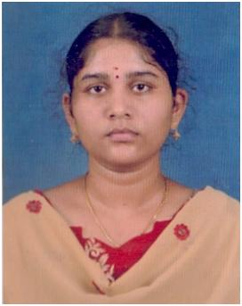 | Name : AALAGU SANKARI.B  Address : D/o S.Balaji  39, v.v.k street,pettai  Tirunelveli-627004  Dob : 05.06.1996  Email Id : sheebasankari0506@gmail.com  Contact no : 9994660609
 | Name : ALMAS FAREETHA.P  Address : D/o Paul Mohamed Meeran.A  45, 3rd cross street, south bala bagya nagar  Tirunelveli-627001  Dob : 16.10.1995  Email Id : almasfareetha@gmail.com  Contact no : 9443352686
 | Name : ANANTH.S  Address : S/o A.Subramanian  243, amman kovil street,  kattudaiyar kudiyruppu-627357  Dob : 28.05.1995  Email Id : fanandpraveen@gmail.com  Contact no : 9524173744
 | Name : ANGEL NANCY. J  Address : D/o A.Joseph Francis  6H, 7th street ,new century nagar, KTC Nagar  Tirunelveli-627011  Dob : 17.11.1995  Email Id : nancyfrancis95@gmail.com  Contact no : 9443581974
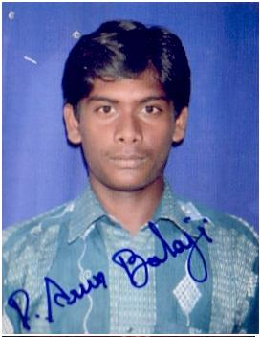 | Name : ARUN BALAJI.P  Address : S/o P.Patchirajan  1/187, West street, Abhisega patti,university post  Tirunelveli-627012  Dob : 26.10.1995  Email Id : arunbala95@gmail.com  Contact no : 9443447054
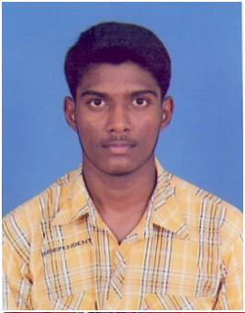 | Name : BALACHANDAR.D  Address : S/o D.G.David  5,1st street, veera manicka puram, Melapalayam  Tirunelveli-627005  Dob : 25.09.1994  Email Id : balubrock25@gmail.com  Contact no : 9790620497
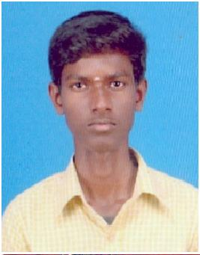 | Name : BALAMURUGAN .P  Address : S/o S.Perumal  95/13B, Jothi nagar 2nd street, kovilpatti  Tuticorin-628501  Dob : 07.07.1996  Email Id : kingbala0707@gmail.com  Contact no : 9894066728
 | Name : BALA NANDHINI.S  Address : D/o P.Saravana Kumar  9/10, Karunanidhi street, gopalasamudram  Tirunelveli-627451  Dob : 12.02.1996  Email Id : psnandhinikumar@gmail.com  Contact no : 9788250166
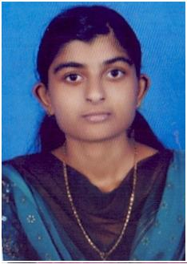 | Name : BENISHA SAMLIN.C.V  Address : D/o C.Victor Sam  17/66, Panagkalaivilai veedu Ponnappanager  Methukumal PO,  Kaliyakkavilai -629172  Dob : 14.08.1995  Email Id : benishasamlinev@gmail.com  Contact no : 9442482653
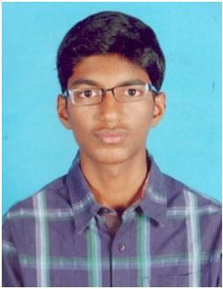 | Name : BLESSING ARON.D  Address : S/o S.David  106K/8A, Chinna mani nagar 1st street  Tuticorin- 628008  Dob : 10.10.1995  Email Id : blessingaron46@gmail.com  Contact no : 9487280013
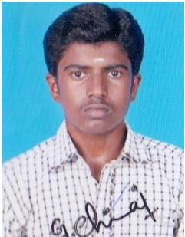 | Name : CHINNA THAMBI.G  Address : S/o M.Guru Samy  11 J, Renganathapuram kovil street  Thalavaipuram- 626122  Dob : 26.02.1996  Email Id : curiouschinna@gmail.com  Contact no : 9791420047
 | Name : DANIEL.L  Address : S/o C.Liberius  2/187, Thomas street,  Veerapandian pattanam - 628216  Dob : 11.01.1996  Email Id : danielfdo11@gmail.com  Contact no : 8148724215
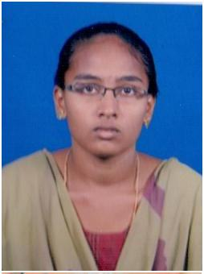 | Name : DEVI ANUSUYA .R  Address : D/o D.Ramachandran  98B, Kadai street  Munaiji patti,nanguneri taluk - 627355  Dob : 27.05.1996  Email Id : devianusuyadeepa@gmail.com  Contact no : 9787421607
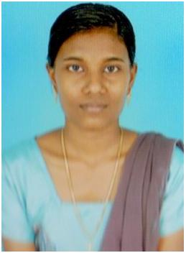 | Name : ELSTAR.X  Address : D/o M.Xavier  1026, Crescent nagar, KTC Nagar  Tirunelveli- 627011  Dob : 18.10.1995  Email Id : elstarrose@gmail.com  Contact no : 9442893038
 | Name : ESAKKIAMMAL.M (10.09.95)  Address : D/o C.Muthiah  2/100c, Muthu ramalingam street,  Muthu ramalingam street,  Tirunelveli- 627351  Dob : 10.09.1995  Email Id : indiranme10@gmail.com  Contact no : 9655165626
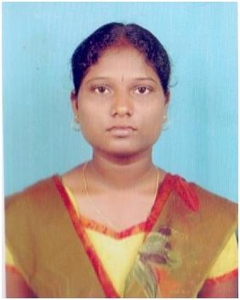 | Name : ESAKKIAMMAL.M (02.12.95)  Address : D/o A.Murugaiah  301/8, Amman kovil street,duraiyoor,  Gangai kondanpost  Tirunelveli- 627352  Dob : 02.12.1995  Email Id : esakkiammal.ramya02@gmail.com  Contact no : 9445424109
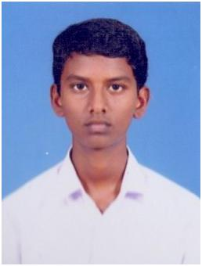 | Name : ESAKKI PANDI.M  Address : S/o K.Mariappan  3/70, West street, Munnerpallam  Tirunelveli- 627356  Dob : 01.06.1996  Email Id : pandi161996@gmail.com  Contact no : 8903860598
 | Name : ESTHER .R  Address : D/o S.Rajasaker  36/410, 19,street shanthi nagar  Tirunelveli- 627002  Dob : 30.11.1995  Email Id : esthere317@gmail.com  Contact no : 9360550594
 | Name : ESTHER CAROLIN.A  Address : D/o S.Arasan  65/3, Pudhugramam middle street  Palayapettai - 627008  Dob : 01.04.1995  Email Id : carolinarosan1@gmail.com  Contact no : 8870157845
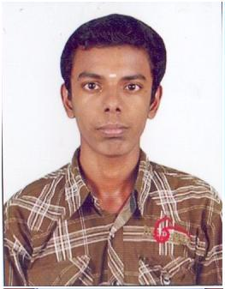 | Name : GANAPATHY RAMAN .D  Address : S/o G.Deivasubramaniam  64A, Siva street, Tirunelveli -town  Tirunelveli- 627006  Dob : 20.06.1996  Email Id : raviganapathyraman20@gmail.com  Contact no : 9486558194
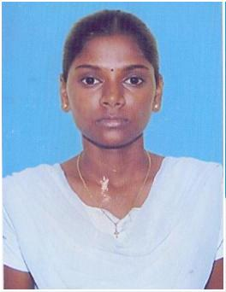 | Name : GNANAM ANTONIAMMAL .T  Address : D/o S.Thanaraj  53/6, East street,alavanthankulam  Pallikottai- 627357  Dob : 23.07.1995  Email Id : roniraj95@gmail.com  Contact no : 9788845639
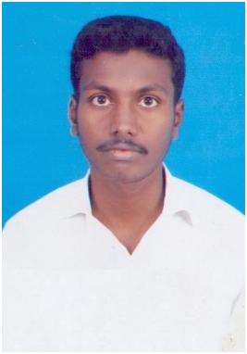 | Name : INBANATHAN.E  Address : S/o N.Elango  25,Elango nagar, Vannarpettai  Tirunelveli- 627003  Dob : 02.10.1995  Email Id : ipsinbanathan@gmail.com  Contact no : 9486304510
 | Name : INDHUMATHI.I  Address : D/o K.Irulapparaj  122/49B, Lakshmiapuram street  Rajapalayam- 626117  Dob : 24.11.1995  Email Id : indhumathiraj24@gmail.com  Contact no : 9443571643
 | Name : ISWARYA.A  Address : D/o K.Arul  53, Indira nagar,  Mamsapuram- 626110  Dob : 05.06.1996  Email Id : ishuananthi96@gmail.com  Contact no : 9498195716
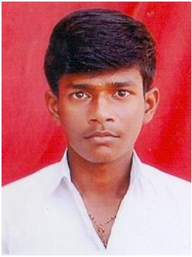 | Name : ITHAYA KUMAR.T  Address : S/o P.Tamil Selvan  1/105, Perumal kovil street, Abishekapatti  Tirunelveli- 627012  Dob : 19.07.1995  Email Id : ithayakumar201@gmail.com  Contact no : 9788751581
 | Name : JASMINE PREEBHA.D  Address : D/o S.Dhas Ravi Kumar  3/234, APT street, kudankulam  Tirunelveli- 627106  Dob : 01.11.1995  Email Id : jaspreebha@gmail.com  Contact no : 9994988405
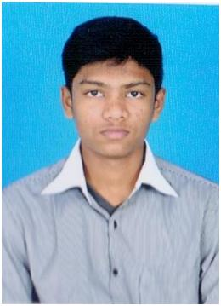 | Name : JEBESTON BLESSING.G  Address : S/o J.Gnanasingh  28, Kailasapuram 2nd street,  Nazareth- 628251  Dob : 22.06.1996  Email Id : jebesbless@gmail.com  Contact no : 9443087316
 | Name : JEGAN.C  Address : S/o V.Chellasamy  4/41, North street, Devarkulam  Tirunelveli- 627022  Dob : 07.01.1996  Email Id : jegansurya7777@gmail.com  Contact no : 7305750818
 | Name : JEYALAKSHMI.R  Address : D/o M.Ramasamy  Middle street ,south ariyakulam, palayamkottai  Tirunelveli- 627351  Dob : 30.10.1995  Email Id : jeyababy87@gmail.com  Contact no : 9791476063
 | Name : JEYA PRAKASH .S  Address : S/o R.Sundarathangam  58A, 3rd street Rajendra nagar, Palayamkottai  Tirunelveli- 627002  Dob : 18.09.1995  Email Id : jeypiprakash@gmail.com  Contact no : 9677402118
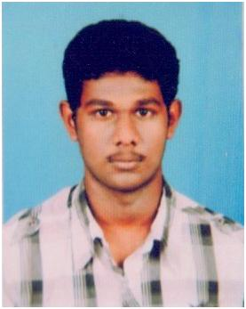 | Name : JOHNSON ASIR. D  Address : S/o A.David Solomon Packiaraj  6, Rama nadar street  Tuticorin- 628 001  Dob : 22.08.1995  Email Id : johnsondja22@gmail.com  Contact no : 9994497601
 | Name : JOSHA.J  Address : D/o J.Jesudurai  3, Happy colony,ambai road , Melapalayam  Tirunelveli- 627 005  Dob : 19.05.1996  Email Id : joshajesuduai@gmail.com  Contact no : 9442319426
 | Name : JUNITHA MARY.G  Address : D/o D.George  50B,north street,  Pohliarpuram- 628653  Dob : 13.11.1996  Email Id : junibabitha@gmail.com  Contact no : 9487050636
 | Name : KALAIYARASI.S  Address : D/o K.Serman  2/167, West street  Kadayalurutti- 627859  Dob : 19.04.1996  Email Id : kalaiyarasikalai@gmail.com  Contact no : 9486585843
 | Name : KANAGADURGA.R  Address : D/o N.Raja  28A, Ramalingar street, vannarpettai,  Tirunelveli-627003  Dob : 13.09.1995  Email Id : kanagadurga1995@gmail.com  Contact no : 9600602962
 | Name : KARTHIKA .M (05.12.95)  Address : D/o N.Marimuthu  79A, Salai street, sindhupoodurai  Tirunelveli- 627001  Dob : 05.12.1995  Email Id : mkarthikaeee1995@gmail.com  Contact no : 9789616704
 | Name : KARTHIKA.M(09.12.95)  Address : D/o S.Muthuraman  115,E/W/S Colony, Phase –II, Perumalpuram  Tirunelveli- 627007  Dob : 09.12.1995  Email Id : karthimuthu38@gmail.com  Contact no : 9487063329
 | Name : KINGSLY JACOB  Address : S/o J.Devadoss  447A/3, Shanthi Nagar, kovilpatti  Tuticorin- 628502  Dob : 06.09.1995  Email Id : kingsleyjacom123@gmail.com  Contact no : 9443088293
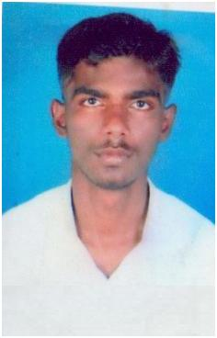 | Name : KINSLEEN .R  Address : S/o M.RamaKrishnan  10F/4, Narayana Sami Kovil Street, Pudhupettai  Tirunelveli- 627004  Dob : 23.04.1995  Email Id : kingslyraj95@gmail.com  Contact no : 9600861957
 | Name : KRISHNAVENI.R  Address : D/o R.Ramasubramanian  2, Navalar Street,  Gopalasamudram- 627451  Dob : 21.08.1995  Email Id : veniram1995@gmail.com  Contact no : 9442455816
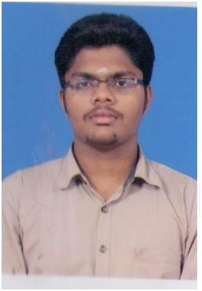 | Name : MAHA PRASANNA.R.G  Address : S/o M.A.Ganeshan  8/14, Tanwa quatress near reporters colony,  palayamkottai  Tirunelveli- 627002  Dob : 16.04.1996  Email Id : rgmprasanna1996@gmail.com  Contact no : 8056724895
 | Name : MAHARASI.E  Address : D/o R.Esakkiappan  D Block,96, Anbu Nagar, Perumalpuram  Tirunelveli- 627011  Dob : 03.02.1996  Email Id : maharasifx@gmail.com  Contact no : 8012865982
 | Name : MAHESWARI.G  Address : D/o P.Ganesan  62/120Z, south street VOC Nagar, sankar nagar  Tirunelveli- 627357  Dob : 25.06.1995  Email Id : mahe95@gmail.com  Contact no : 7418878246
 | Name : MAHESWARI.S  Address : D/o S.Sundaram  3B, Gomathiyapuram,3rd Street, Sankarankovil,  Tirunelveli- 627756  Dob : 22.09.1995  Email Id : maheshwarifxeee@gmail.com  Contact no : 9750512679
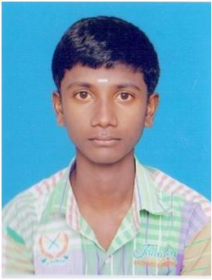 | Name : MANIKANDAN .V  Address : S/o A.Vairamuthu  1A,Narayanaswamy kovil north street,  Pazhayapettai- 627008  Dob : 22.09.1995  Email Id : manik8775@gmail.com  Contact no : 9442801657
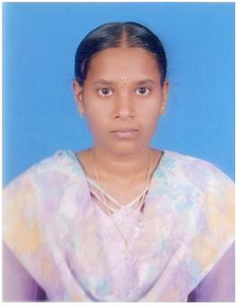 | Name : MARIYA JOICY.S  Address : D/o A.Stephen Raj  151/1, Thamirabharani nagar,south street  Vikramasingapuram- 627428  Dob : 05.02.1996  Email Id : stephenjoicy@gmail.com  Contact no : 9952320093
 | Name : MARIAPPAN.S  Address : S/o A.Sudalai Mani  189/3, south street, moondradaippu  Tirunelveli- 627152  Dob : 15.05.1995  Email Id : spmari.anandh@gmail.com  Contact no : 9566913162
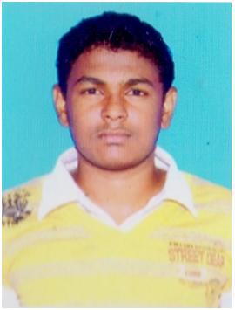 | Name : MOHAMED ADIL.N  Address : S/o S.M.Naina Mohamed  54/B1, Periya kothpa pallivasal,North east street  Melapalayam  Tirunelveli- 627005  Dob : 15.03.1996  Email Id : madilcrze@gmail.com  Contact no : 9486140472
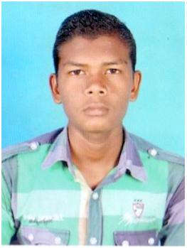 | Name : MOSES RAJ.J  Address : S/o M.Jeya Mani  East street ,Elango nagar, Vannarpettai  Tirunelveli- 627003  Dob : 18.04.1996  Email Id : mosesraj478@gmail.com  Contact no : 9345621932
 | Name : MUTHUVEL.A  Address : S/o M.Antony  93,manonmanium sundaranar street, ponnakudi  Tirunelveli - 627151  Dob : 12.01.1996  Email Id : muthuvelsmartfxeee@gmail.com  Contact no : 8973705255
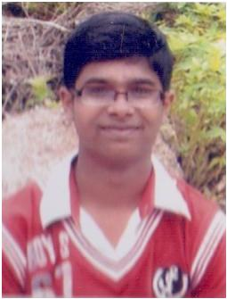 | Name : NAGARAAJ.P  Address : S/o M.Perumal  14, NJS illam,melakarai new colony,  Thatchanallur  Tirunelveli – 627358  Dob : 28.02.1996  Email Id : nagaraajnaveen@gmail.com  Contact no : 9345628743
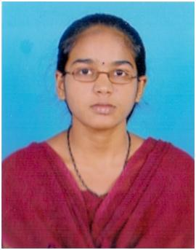 | Name : NALLAMMAL.A  Address : D/o C.Arumugam  131, senaiyar Mettu street  Kallidaikurichiu- 627416  Dob : 20.12.1995  Email Id : sankarinalls@gmail.com  Contact no : 8526156850
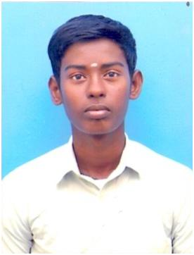 | Name : BALACHANDRAN.S  Address : S/o S.Seetha Raman  6/1, Kamarajar street, Moolaikaraipatti  Tirunelveli- 627354  Dob : 16.03.1996  Email Id : balu.mullaiking@gmail.com  Contact no : 9994231173
 | Name : HARI SHANKAR.M  Address : S/o S.Muthu Subramanian  39, Salai street, Sindupoondurai  Tirunelveli -627001  Dob : 21.06.1995  Email Id : shankarhari186@gmail.com  Contact no : 9443736640
 | Name : JERIN JEYARAJ.A  Address : S/o J.S.E.Asirvatham  1H, Thimyaar colony,  Tuticorin- 628008  Dob : 18.09.1995  Email Id : jerinjeyaraj034@gmail.com  Contact no : 9442813804
 | Name : MARI RAJA  Address : S/o M.Mariappan  99, east street,  Vadakkuputhur- 627755  Dob : 04.01.1992  Email Id : magarajammr@gmail.com  Contact no : 7502761078
 | Name : MOHAMMED SALAHUDEN JAILANI  Address : S/o P.Ahamed Musthafa  9/98A, Middle street,Mela thalaiyuthu  Sankar nagar- 627 357  Dob : 15.08.1996  Email Id : msjailani333@gmail.com  Contact no : 9488783902
 | Name : MURUGESAN.N  Address : S/o M.Narayanan  3/163, indira nagar,  vittilapuram -628809  Dob : 15.11.1995  Email Id : msmuruges6232@gmail.com  Contact no : 9965243025
 | Name : MUTHU RAJA.V  Address : S/o M.Vadivel  22/137.A, amman kovil north street,  Karuppandurai- 627006  Dob : 15.11.1996  Email Id : muthuraja513@gmail.com  Contact no : 9677959602
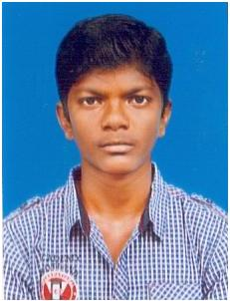 | Name : PREM KUMAR. J  Address : S/o D.John  1/44, north street,  Parvathiyapuram- 627201  Dob : 05.11.1994  Email Id : johnpremselvi@gmail.com  Contact no : 9443291129
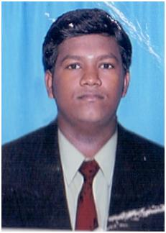 | Name : SANTHANA MARI. A  Address : S/o S.Arumugam  7/9, Thangamman kovil street  Nadukallur- 627010  Dob : 06.01.1995  Email Id : santhanamarinellai@gmail.com  Contact no : 9578595339
 | Name : SELVAKUMAR. P  Address : S/o A.Perechinathan  20/B, Perachi amman kovil street, Vannarpettai  Tirunelveli-627003  Dob : 03.12.1994  Email Id : lakshmiselva368@gmail.com  Contact no : 8760242071
 | Name : SHEIK DIWAN.M  Address : S/o D.Mohideen  28/39 ,2I Gnaniyarappa nagar 8th street,  Melapalayam  Tirunelveli- 627005  Dob : 29.10.1995  Email Id : sheikdiwanalterthinker@gmail.com  Contact no : 9940927992
 | Name : SOWMYA RAJASELVI.M  Address : D/o P.Meenakshi Sundaram  129, circle office street  sankar nagar  Tirunelveli- 627 357  Dob : 09.02.1996  Email Id : sowmyarajaselvi@gmail.com  Contact no : 9488478842
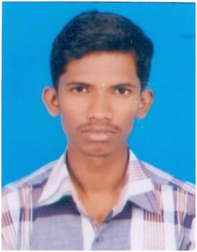 | Name : VASANTH.R  Address : S/o P.Rama Krishnan  2/118, periyar nagar, thenkalam  Tirunelveli- 627 357  Dob : 13.08.1996  Email Id : vasanthspc@gmail.com  Contact no : 9597876712
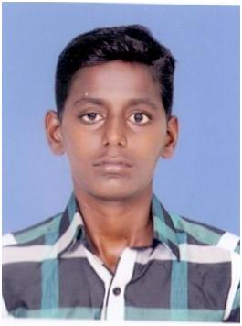 | Name : VICTOR THAMAS.M  Address : S/o A.Mariadasan  21/117A, South street, Arokiyanathapuram  Tirunelveli- 627011  Dob : 29.11.1993  Email Id : victorthamas1993@gmail.com  Contact no : 9626868806
 | Name : VIJAY RAGAVAN.P  Address : S/o R.Pavalavannan  24/7, periyar street,  Padikuppam - 600107  Dob : 02.12.1993  Email Id : vijayragavanps@gmail.com  Contact no : 9003190826
 | Name : JOEL MIRACLESON J  Address : S/o M.Jeyasingh  30/161, 1st main street,NH colony  Perumalpuram- 627007  Dob : 27.08.1995  Email Id : joelmiracleson@gmail.com  Contact no : 9994637218

